1. Agenda:
   1. Introduction to the project, we will use in this section.
2. This is the same 3 projects we used in last section with just a little change.
3. 
4. 
5. 
6. 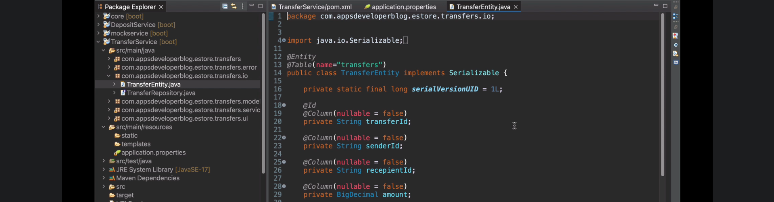
7. 